UK Train Rides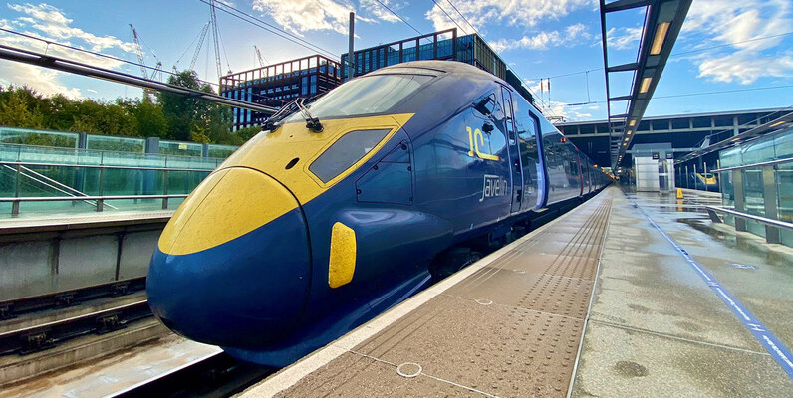


DATA5IVE
Team members:
- Nadia Hesham Shalan
- Fatma Hatem Abdelatif
- Mona Ahmed AboHola
- Noran Gamal khattab
- Elaph Othman mohammed

Dataset: railway.csv (Kaggle)
link: https://www.kaggle.com/datasets/motsimaslam/national-rail-uk-train-ticket-data
Clean process:
- Delay Minutes: the difference between actual and scheduled arrival time, with negative values adjusted to 0
- Is Delayed: a binary flag (0 = On Time, 1 = Delayed)
- Journey Duration (Minutes): calculated duration between scheduled departure and arrival times
- Purchase Day: the weekday on which the ticket was purchased
- Journey Day: the weekday on which the journey took place
- Revenue Category: ticket price grouped into three categories (Low, Medium, High)
- Delay Reason Category: simplified into two groups: No Delay or Has Delay Reason
- Filled missing values in Reason for Delay with No Delay
- Replaced missing Actual Arrival Time with the scheduled arrival time when the journey was recorded as On Time
- Remaining missing values in Actual Arrival Time were replaced with Unknown
- Converted Date of Purchase and Date of Journey into proper datetime format for consistency
- Created complete datetime columns (Departure DateTime, Arrival DateTime, and Actual Arrival DateTime) to enable accurate time-based calculations
- Created three columns:
(Daytype of Purchase): whether the day is weekday or weekend
(MonthName): name of the month
(Daytime): Morning or Evening

